Prayer Points
ROCKHAMPTON CHURCHES COVENANT OF PRAYER
Northside Family Church, (Thorn St Assembly)

WORLD COUNCIL OF CHURCHES
United Church in PNG

- All the Churches within Australia, Our Nation and Our Leaders.
- The Joint Nominating Committee and members of Church Council.
- Rev Nathan Barton and our Lay Preachers.
- Our Partner Church, Clermont/Capella Congregation and their leader Heather James.
- Church Volunteers – for those responsible for counting the offering
& weekly banking.
- Iloura Child Care Centre – for the staff, children and their families.

LECTIONARY READINGS
18th April | 25th April
Easter 3 | Easter 4
Acts 3 : 12-19 | Acts 4 : 5-12
Psalm 4 | Psalm 23
1 John 3 : 1-7 | 1 John 3 : 16-24
Luke 24 : 36b - 48 | John 10 : 11-18

Some thoughts on Luke 24:36-48 –
Peace is not just the absence of conflict, but a deep sense of knowing all will be well! As he appears he so often says firstly ‘do not be afraid’!’ Am I fearful? Do I need to pray for trust in God, trust in my life, maybe an important relationship which is strained?
What is it like for me to be invited to touch his wounded hands, feet or side? and allow me to be a bit more convinced of his profound love?
 | 18th April  Easter 3 - HC | 25th April  Easter 4
PREACHER | John Wagstaff | David Horton
ELDER | Sharon Dekkers | Ros McKendry
BIBLE READER | David Horton | Leonie Lester
MUSICIAN | Margery Cass | Syd Stickley
PRAYERS OF THE PEOPLE | Sharon Dekkers | Caroline Holmes
PRAYERS AFTER WORSHIP | Narelle Bungey | Edith Plumb
MORNING TEA | Faye Fay | Narelle Bungey
STEWARDS | Team B | Team B
WEDDINGS & FUNERALS | Ros McKendry | Ros McKendry
MOWING | Col McKendry &  Kelvin McLean | Col McKendry &  Kelvin McLean
If you are unavailable on your rostered day,
please organise for someone to fill in and
note it on the roster

It was revealed to them that they were serving not themselves but you, in regard to the things that have now been announced to you through those who brought you good news by the Holy Spirit sent from heaven—things into which angels long to look!
1 Peter 1:12

-PRAYER CHAIN-
-This is a confidential Prayer Chain -
Sally Sutherland is the Prayer Chain Co-ordinator.
Please either ring Sally on 4936 4025
Or email prayer@northrockyuc.org.au

Are all your details up to date?
Address, email and telephone numbers. If any of these have changed or need updating, please let the office know. Telephone 4926 1315 or email - office@northrockyuc.org.au

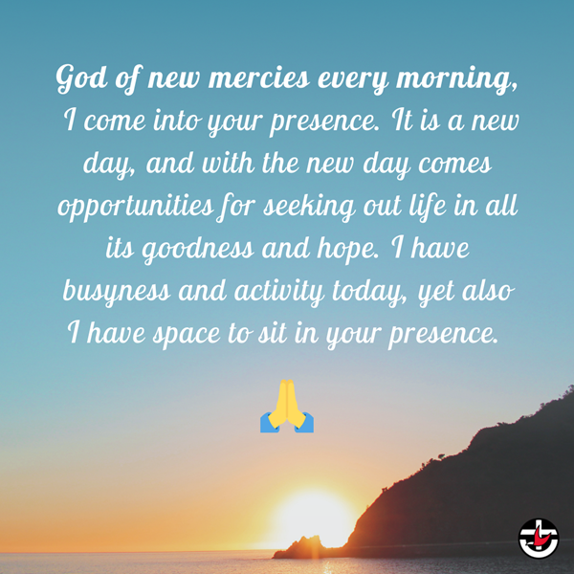
National Uniting Church news

Moderator’s Prayer

Lift up your eyes: Seven Days of Solidarity is here!
Looking for inspiration? From Sunday 18 April, UnitingWorld is sharing stories of joy and triumph inspired by the work of our global partner churches and celebrating the risen Christ at work! UnitingWorld holds these partnerships on behalf of the people of the Uniting Church and we share these stories to inspire you in faith and action.
COVID-19 continues to make life so difficult for our church partners, but through it all, God is faithful. Their incredible lives remind us that we’re surrounded by a cloud of witnesses who keep the faith, and giving up is not an option.
Welcome to Seven Days of Solidarity, a celebration of our Global Neighbours
UnitingWorld connects you to the global church.
Each day we’ll tell you story of God changing the world through one of our partner churches.
Celebrate! And join the movement and do your part.
Pray. Change. Give.
https://donate.unitingworld.org.au/7dos

Faith is to believe, on the word of God, what we do not see,
THOUGHT of the day

and its reward is to see and enjoy what we believe.

Meetings

MARK

YOUR

DIARY
May 6 2pm Pastoral Care
May 15 2 – 5 pm Vision Day

Studies
Activities
May 7 Friday Street Stall for Chaplaincy
May 8 8 – 12 am Market Day
Thursdays 9:30am Mainly Music in the hall

Mainly Music
We currently have vacancies in our programme -

RESUMING Thursday 22 April!!

If you need any information please contact
Jan McLean 4928 3783 or the office.

This is a terrific programme, an outreach, run by a very small number of hard working volunteers. If you are available to assist in any way, for just an hour a week –
it would be most welcome.

Scripture Union Queensland
Prayer Guide
April 19-20
Please pray for our teachers as Term 2 starts up. May they be refreshed and ready to inspire our young people.

The next Caves Service will be held
2 May.
All welcome.

COVID UPDATE
We are mask free!
Please continue with social distancing and please ensure that you are following the seating arrangements set out in the church – only sit where the dots are, family groups can sit together. Follow all guidelines during Communion and at morning tea.
If you are unwell, please remain at home and recover.

Lions Recycle for Sight Australia
Don’t throw away your old glasses!!

Lions Club can use them to help save the sight of people living in third world countries.
The Australian programme has operated for over 26 years and has delivered over 7 million pair of refurbished quality spectacles to men, women and children in need and without the financial capacity to purchase even the cheapest pair, to many countries in Africa, Europe, Middle East, Indian Sub-continent, East Asia and the Far East, China, the countries of the Pacific Rim and Southern Asia and Oceania.

There is a box in the narthex where you can leave your glasses.

HALL HIRE
Did you know our Hall is available for hire!
If you know of anyone who is looking for a space, please give them our details.

NEXT MARKET DAY IS 8TH MAY!

LIVESTREAMING –
South Rockhampton Uniting Church are continuing with Live Streaming of their weekly services at 9:00am. Please note that the link is – https://southrockyuc.online.church . If you are looking for other Livestreaming options – please go to the Qld Synod website – Coronavirus Resources/Live Streaming Worship – for a full list of all churches offering Live Streaming.

We are appealing for more helpers.
Morning tea

If the Morning Tea person is on their own, please offer to help for a short time.

We are also allowing donations of home cooking for morning tea. This will need to be served in COVID Safe manner. Faye, Susanne, Leonie, Lesley, Narelle, Margaret and Ros have completed online training. Others are encouraged to do so.

Feel free to bring in food, hopefully before morning worship begins. If you can cut into separate pieces prior to this it would be appreciated.

If you don’t want to be on the Roster, but feel able to supply some food, this can be accepted and frozen for future occasions if necessary.

Thank you for your co-operation with this time of fellowship.

Task | Duties | Contact
Morning tea | Go on roster to assist -with more helpers we can have two in a team. | Leonie, Ros, Narelle
Stewards | Open and close church, greet at door, collect and count offering. | Narelle, Ros
Prayers of People | On roster each 5-6 weeks. Prepare and say prayers. Can be done seated if needed. Tuition is available. | Narelle
Elders, church councillors | To attend one meeting a month and other duties as rostered. | Bob

A Vision Day is planned for
When: Saturday 15 May 2021 at 2 – 5 pm
Where: Church Hall
Who: You, me and the whole of the congregation

The path the Lord calls us to walk can have many twists and turns. As a congregation we need to constantly seek Him to make sure we are walking the way He wants us to be. Please join us as we listen to God and listen to each other and explore where God's path is leading us today.

Contact Details
Rev Nathan Barton  Supply Minister | rev.nathan.barton@gmail.com  0429 632 527
Office e-mail | office@northrockyuc.org.au
 | Telephone: 4926 1315
Office Hours | Thursdays 9:00am - Noon
Street Address | 321 Berserker Street, Frenchville Qld 4701
Postal Address | P O Box 10185, Frenchville Qld 4701
Web site | www.northrockyuc.org.au
Face Book Page | www.facebook.com/NorthRockyUC/  Search: North Rockhampton Uniting Church
Treasurer | treasurer@northrockyuc.org.au
Prayer Chain | prayer@northrockyuc.org.au
Prison Chaplain | Mr David Horton – 0428 965 203
Hospital Chaplain | Rev Ann Hewson – 0468 490 799
BlueCare Chaplain | Pastor Donna Muston – 0427 112 057

Direct Debit/Giving
Account Name: UCA Fitzroy Parish Direct Debit Account
Account BSB/Number: BSB 014-010 Account Number 210834046

If you are unable to attend worship and wish to make a direct deposit –
Please use the following details:

Donations Account
Account Name: UCA Fitzroy Parish PCP
Account BSB/Number: BSB 014-010 Account Number 210834038

If you are unsure how to use this method, or would like information
regarding your weekly giving and/or Direct Debit arrangements,
Please speak to our Treasurer David Horton 0428 965 203.
email: treasurer@northrockyuc.org.au
Have you looked at our Website –

www.northrockyuc.org.au
North Rockhampton Uniting Church
SUNDAY 18 APRIL 2021
EASTER 3 - WHITE
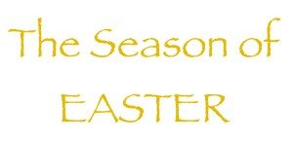

If you are visiting today, we welcome you!
Please join us in the hall after worship to share a cuppa.

PARISH MISSION STATEMENT
Serving God through Christ in Church and Community.

